**LIGHT-REFLECTION AND REFRACTION**

**CASE STUDY-X**

**I.Answer the questions that follow on the basis of your understanding of the following paragraph and the related studied concepts:**

A taxi driver was driving his taxi on road. Suddenly in his rear-view mirror, he saw an over-speeding car coming from behind as if the he had lost his control over the car. The taxi driver immediately turned his car towards the side of the road and stopped. Soon after that the speeding car collided with another car ahead and met with an accident. The taxi driver came out of the car and went towards the accident site. He took the injured person to the nearby hospital.

a) What type of mirror is used for rear-view in the car? Mention the nature of the image formed.

b) Name the mirror that can form both real and virtual image. Also draw the ray diagram of a concave mirror when the object is placed between principal focus and pole of the mirror.

c) Plane mirrors are not used as rear-view mirrors in vehicles. Give reason d) Draw the ray diagram of a convex mirror when the object is placed

anywhere between infinity and pole of the mirror.

**II.Analyse the following observation table showing the variation of image distance (v) with respect to the object distance (u) in case of a convex lens**

**and answer the questions that follow, without doing any calculations:**

S.N

Object distance(u)

cm

Image distance(v)

cm

1 -100 +25

2 -60 +30

3 -40 +40

4 -30 +60

5 -10 + 100

a) State the lens formula. What is the focal length of the given convex lens

b) Write the serial no. of the observation that is not correct. Why

c) Using an appropriate scale draw the ray diagram for the observation serial no.4

d) Under what condition does a biconvex lens of glass having a certain

refractive index act as a plane glass sheet when immersed in a liquid?

**III. Answer the questions that follow on the basis of your understanding of the following paragraphst and the related studied concepts**

**I Colourful clothes, colour television and the flashing coloured lights in a disco all help to make life brighter. It was Newton who, in 1666, set us on the road to understanding how colours may arise. He produced them by allowing sunlight (which is white) to fall on a triangular glass prism. The band of colours obtained is a spectrum and this phenomenon is dispersion**

**1. For which colour refractive index of glass is maximum?**

**a)Red b) Violet c) Yellow d)Green**

**2. The seven coloured light of a spectrum can be recombined when two prisms are placed in**

**a) Horizontal position with respect to each other. b) Adjacent position with respect to each other**

**c) Inverted position with respect to each other**

**d) Vertical position with respect to each other**

**3. When white light enters into a prism, it gets split into its constituent colours. This is due to**

**a) Different refractive index for different wavelength of each**

**colour**

**b) Each colour has same velocity in the prism c) Prism material have high density**

**d) Scattering of light**

**4 The angle between incident ray and emergent ray of prism is called**

**a)Angle of incidence b) Angle of deviation**

**c) Angle of emergence**

**d) Angle of refraction**

**5 Which of the following is a natural phenomenon caused by the dispersion of sunlight in the sky**

**a) Twinkling of stars**

**b) Stars seem higher than they actually are c) Advanced sunrise and delayed sunset**

**d) Rainbow**

**IV . Light scattered by fine particles whose size is comparable to the wavelength of light. This can be demonstrated by a simple experiment.**

**A few drops of sulphuric acid are added to a glass tank containing sodium thiosulphate solution. An intense beam of white light is passed through the tank and the emergent beam allowed to fall on a screen. Due to the action of the acid, Sulphur is precipitated in the form of tiny particles. The emergent beam is found to be orange – red in colour , indicating that the blue and violet colour are removed from**

**white light by scattering.**

**1 The danger signals installed at the top of tall buildings are red in colour. These can be easily seen from a distance because**

**among all other colours , the red light a)is scattered the most by smoke or fog b) is scattered the least by smoke or fog**

**c) is absorbed the most by smoke or fog d) moves fastest in air**

**2 The clear sky appears blue because**

**a) blue light gets absorbed in the atmosphere**

**b) ultraviolet radiations are absorbed in the atmosphere**

**c) violet and blue lights gets scattered more than the lights of other colours by the atmosphere**

**d) lights of all other colours is scattered more than the violet**

**and blue colour lights by the atmosphere.**

**3 Twinkling of stars is due to atmospheric a) dispersion of light by water droplets**

**b) refraction of light by different layers of varying refractive indices.**

**c) scattering of light by dust particles d) internal reflection of light by clouds**

**4 At noon sun appears white as a)light is scattered the least**

**b) red colour is scattered the most c) Blue colour is scattered the most**

**d) all the colours of the white light are scattered away**

**5 Scattering caused by microscopic solid particles suspended in a liquid or gas is called**

**a)Dispersion b) Atmospheric refraction c) Raman effect d)Tyndall effect**

CHAPTER- 12 ELECTRICITY

V A continuous conducting path between the terminals of a source of electric energy and other electrical components along which the electric current flows is called an electric circuit. Types of electric circuits - 1.Closed electric circuit 2. Open circuit

Open electric circuit: It is the circuit in which electric contact is broken at some point such that no current flows through the components of the circuit.

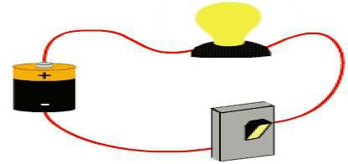

Closed electric circuit: The circuit in which all the components of a circuit are joined to one another such that a continuous current flows through

them is a closed electric circuit. The direction of flow of electrons gives the direction of electronic current. Ammeter is a device used to measure electric current in an electric circuit. Electric current is expressed by the

amount of charge flowing through a particular area in unit time.

1.A charge of 100 C flows through a bulb in 5 minutes. How much current is flowing through the bulb?

(a) 500 A (b) 100 A

(c) 20 A (d) 0.3 A

2. A circuit has a charge of 2C moving through it in 3 s. Which electrical component in the circuit, if present, will show the current?

(a) Voltmeter will show a current of 6 A. (b) Ammeter will show a current of 0.7 A. (c) Rheostat will show a current of 0.7 A. (d) Resistor will show a current of 0.35 A.

3.The image shows a circuit diagram.

What is being measured using the voltmeter? (a) current in the circuit

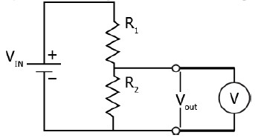

(b) voltage in the circuit

(c) voltage across the resistor

(d) resistance offered by the resistor

4. How many electrons can pass through an electric lamp in one minute if the current is 300mA? (1.6 × 10−19𝐶)

(a) 1.125 × 1020 (b)1.125 × 1019 (c) 1.125 × 1017 (d)3.125 × 1020

5. A conducting wire carries 1021 electrons in 4 minutes. What is the current flowing through the wire?

(a) 40 A

(b) 7 A (c) 4 A (d) 0.7 A

VI The resistivity of a conductor is given by the expression 𝜌 = 𝑅𝐴/𝑙 where

R is the resistance of conductor of length *l* and area of cross section *A*. the

resistivity of a conductor is independent of dimensions of conductor. It depends on the nature of material and temperature of conductor. When a number of resistors are connected in series, the effective resistance is the sum of the individual resistances. The value of the equivalent resistors is smaller than the smallest resistance in the group.

1. Which one among a bar of an alloy of mass 2 kg and a 3 kg iron bar of same dimension has greater resistivity?

(a) Iron bar because it has higher mass. (b) Alloy bar because it has lower mass.

(c) Iron bar because it has same types of atoms.

(d) Alloy bar because it has different types of atoms.

2. A piece of wire is measured to have resistivity in the order of 1019 Ω

m. What should its material be classified into? (a) Alloys

(b) Insulators

(c) Good conductors

(d) Poor conductors

3. Which combination of a 2 Ω resistor and 4 Ω resistor offers the least

resistance to current in the circuit?

(a) Series combination, which results in a net resistance of 2 Ω. (b) Parallel combination, which results in a net resistance of 2 Ω.

(c) Series combination, which results in a net resistance of 1.5 Ω.

(d) Parallel combination, which results in a net resistance of 0.5 Ω.

4. The image shows a combination of 4 resistors.

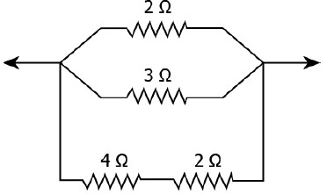

What is the net resistance between the two points in the circuit?

(a) 0.5 Ω (b) 1.0 Ω (c) 1.5 Ω

(d) 2.0 Ω

5. A given wire having resistance R is stretched so as to reduce its diameter to half its previous value. What will be the new resistance?

(a)16R (b)4R (c)R (d)R/16

**VII .Electromagnetic induction**

The induction of an electromotive force by the motion of a conductor across a magnetic field or by a change in magnetic flux in a magnetic field is

called **‘Electromagnetic Induction’.**This either happens when a conductor is set in a moving magnetic field or when a conductor is always moving in a stationary magnetic field.Suppose while shopping you go cashless and your parents use cards. The shopkeeper always scans or swipes the card. Shopkeeper does not take a photo

of the card or tap it. Why does he swipe/scan it?.

Can moving objects produce [electric currents? How to determine a relationship](https://www.toppr.com/guides/physics/electricity/electric-current-and-circuit-diagrams/) between electricity and magnetism? Can you imagine the scenario if there were no computers, no telephones, no electric lights. The experiment of Faraday has led to the generation of generators and transformers. This law of electromagnetic induction was found by **Michael Faraday.** He organized a leading wire according to the setup given underneath, connected to a gadget to gauge the voltage over the circuit. So when a bar magnet passes through the snaking, the voltage is measured in the circuit. The importance of this is a way of producing electrical energy in a circuit by using magnetic fields and not just batteries anymore. The machines like

generators, transformers also the motors work on the principle of electromagnetic induction.

• First law: Whenever a conductor is placed in a varying magnetic field, EMF induces and this emf is called an induced emf and if the conductor is a closed circuit than the induced current flows through it.

• Second law: The magnitude of the induced EMF is equal to the rate of change of flux linkages.

Based on his experiments we now have Faraday’s law of electromagnetic induction according to which the amount of voltage induced in a coil is proportional to the number of turns and the changing magnetic field of the coil.

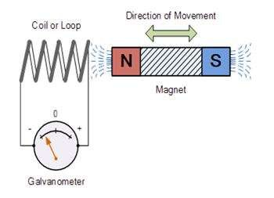

ANSWER THE FOLLOWING QUESTIONS-

1. State which rule to determine the direction of a current induced in a coil due to its rotation in a magnetic field. (1 mark)

2. What do you mean by magnetic flux? Write its unit. (1 mark)

3. If there is no relative motion between magnet and the coil, then there is no deflection in the galvanometer. why? (1 mark)

4. How does this swiping deduct money from the card? (1 mark)

5. The value of induced Electromotive force (EMF) is directly proportional to -

------ (1 mark)

A. current through coil

B. voltage applied C. no. of field lines D. resistivity

**VIII. Electric Motor**

Electric motor is a device that converts **electrical energy to mechanical energy.**

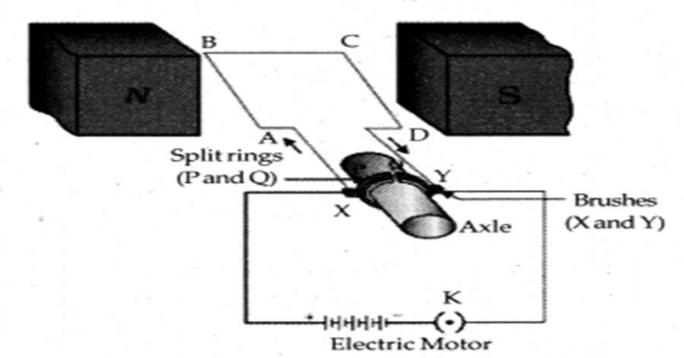

**Parts of a Electric Motor**

o **Insulated Copper wir**e: A rectangular coil of wire ABCD

o **Magnet Poles**: A magnet as placed above ie North Pole and South Pole. This creates a magnetic field as shown above.

o **Split Rings**: Two disjoint C-shaped rings P and Q. It acts as a commutator

(which can reverse the direction of current)

o **Axle**: The split rings are placed on the axle which can rotate freely.

o **Brushes**: The outside of the split rings are connected to conducting brushes X

and Y.

o **Source Battery**: To source current.

**Working**

o When the current begins to flow, current flows through **brush X, then A to B,**

**B to C, C to D and then to brush Y and into the battery.**

o Now applying **Fleming's Left Hand Rule** to wire AB, Current is along **AB**,

Magnetic Field is as shown (North-> South), the motion of the wire is **downwards**.

o Now applying **Fleming's Left Hand Rule to wire CD**, Current is along **CD**,

Magnetic Field is as shown (North-> South), the motion of the wire is **upwards**.

o The rectangular coil begins to move in the **anti-clockwise direction**

o Note that during anti-clockwise motion, the split rings and axle also move, whereas the brushes don't move.

o After half a rotation, **Wire CD and Split ring Q moves to the left. Wire AB**

**and Split ring P moves to right.** Brushes X and Y donot move.

o Now applying **Fleming's Left Hand Rule** to wire CD, Current is along **DC**. (Battery -> Split ring Q ->DC , Magnetic Field is as shown (North-> South), the

motion of the wire is **downwards**.

o Now applying **Fleming's Left Hand Rule** to wire AB, Current is along **BA**. (Battery -> Split ring Q -> DC --> CB -> BA --> Split ring P) , Magnetic Field

is as shown (North-> South), the motion of the wire is **upwards**.

o So, again the coil rotates in the **anti-clockwise direction.**

o The reversal of current in the coil results in the continous rotation of the coil. **The reversal of current is achieved by the commutator rings**

**Applications**

o Electric Fans o Refrigerators o Mixers

o Washing machines

ANSWER THE FOLLOWING QUESTIONS

1. Which of the following rule is used to determine the direction of rotation of

D.C motor?

A. Coulomb’s Law

B . Right hand Thumb Rule

C .Fleming’s Right-hand Rule

D. Fleming’s Left-hand Rule

2. In which of the following applications, DC series motor is used? A. Centrifugal Pump

B. Motor Operation in DC and AC C. Water pump drive

D. Starter for car

3. Excessive sparking at the brushes may be caused due to

A. Unequal Space

B. Dirt in commutator

C. Overload

D. All of the above

4. In a rectangular coil, if BCis perpendicular to the magnetic field on which direction forceacts on BC.

A. Upward

B. Downward

C. Left side

D. Right side

5. In a rectangular coil, if AD is perpendicular to the magnetic field on which direction force acts on AD.

A. Upward

B. Downward

C. Left side

D. Right side